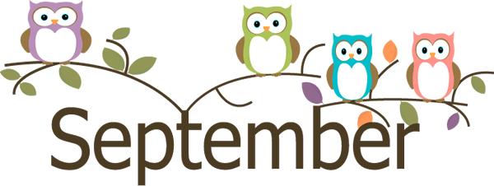

Mrs. Rogge’s Snack Calendar
- Please send enough pre-portioned snacks and spoons (if necessary) for 20 scholars. Thank you!
- Your child will also be the classroom “Noodle Master” on this day!

Sunday | Monday | Tuesday | Wednesday | Thursday | Friday | Saturday
 | August 27  Kindergarten Conferences | August 28  Kindergarten Conferences | August 29  Ella  Happy Birthday | August 30  Leo | August 31  Harriet | 1
2 | 3  No School! Labor Day | 4  Huck | 5  Davis | 6  Vincent | 7  Ben | 8
9 | 10  Amira | 11  Gus | 12  Gretchen | 13  Keagan | 14  Vera | 15
16 | 17  Elisa | 18  Grace | 19  Zana | 20  Louis  Meet the Teacher (6:30) | 21  William  Happy Birthday | 22
23 | 24  Gabriel | 25  Adelaide | 26  New  Scholar | 27  Ella | 28  Leo | 29
30 | October 1  Harriet | 2  Huck | 3  Davis | 4  Vincent | 5  Ben | 6  Barnes & Noble Book Fair

