University of West Alabama
5E Lesson Plan Template
Unsolved Mysteries Research Project
Teacher: Heather Bozzelli
Date: 1/30/19
Subject area/course/grade level: English Language Arts/6th Grade
Materials: Pencils, research paper notes, Chromebooks, sources, PowerPoint
Standards (State and ISTE Standards for Students):
State Standards:
27) Conduct short research projects to answer a question, drawing on several sources and refocusing the inquiry when appropriate. [W.6.7]
29) Draw evidence from literary or informational texts to support analysis, reflection, and research. [W.6.9]
ISTE Standards:
1) Empowered Learner - Students leverage technology to take an active role in choosing, achieving and demonstrating competency in their learning goals, informed by the learning sciences.
2) Digital Citizens - Students recognize the rights, responsibilities and opportunities of living, learning and working in an interconnected digital world, and they act and model in ways that are safe, legal and ethical
6) Creative Communicator – Students communicate clearly and express themselves creatively for a variety of purposes using the platforms, tolls, styles, formats, and digital media appropriate to their goals.
7) Global Collaborator – Students use digital tools to broaden their perspectives and enrich their learning by collaborating with others and working effectively in teams locally and globally.

Objectives:
- Students will be able to research to build and present knowledge.
- Students will draw evidence from digital resource informational texts to support analysis, reflection, and research.
- Students will be able to work with a group to meet a common goal.
- Students will be able to communicate ideas and knowledge by creating a PowerPoint about a specific unsolved mystery.
- Students will be able to publish or present material for their audience.
Differentiation Strategies (How will the lesson address the various learning styles of the students and the needs of those with special needs?):
- This product includes resources and student handouts based on the Big6 Research Model in order to provide them with guidance, structure, and help throughout each research step. Big6 is a six-stage inquire-based model to help students solve problems or make decisions by using credible information.
- Students will be working in diverse groups based on specific needs.

ENGAGEMENT:
What are mysteries? What about the mysteries that never get solved? Why hasn't anyone found the answers?
- Teacher will explain to the students that they will be selecting a topic on an unsolved mystery where they will be researching and creating a PowerPoint with a partner.
- To expose the students to the different types of topics, the teacher will show a picture slideshow on Google docs consisting of the different topics: https://docs.google.com/presentation/d/1Juz8tKW2Gb1qUJq-q4WHZe1WNY6FjFBESExw9CTumnQ/present?slide=id.g1562fd85ac_1_31
- The topics consist of: Bigfoot, The Loch Ness Monster, Aliens and UFOs, The Lost City of Atlantis, Mary Celeste, The Bermuda Triangle, and Easter Island.
- The teacher will show the Google Doc that consists of each topic and a brief summary of what is about and the students will decide which one is most interesting to them. https://sites.google.com/view/unsolved-mysteries-ttu/step-1-task-definition

The teacher will then ask the students: Which mystery will you research? What information do you know or think you know about the topic? What questions do you have? What would you like to find out about the unsolved mystery?

Student will be given a pre-research inquiry handout that will be turned in for assessment.

Assessment: The students will be provided with a pre-research inquiry handout that contains: The topic of interest, what I know, and questions I have. They will turn that in for participation points.
https://docs.google.com/document/d/1y8K-Z1JwR3g-ER2fJ-Oa4XA1vvNWO2PnEAMuvDw0G4M/edit
EXPLORATION:
- The teacher will remind the students what their topic is, and assign them partners depending on which topic they have chosen.
- During this time, the teacher will provide the students with a research handout and links, so they can access their topic information.
- Teacher will review the steps on how to get into the website and find their topic and websites.
- Students can reach their links by going to this website: https://sites.google.com/view/unsolved-mysteries-ttu/step-4-use-of-information and signing into their school account.
- Each topic contains 6 suggested online websites. The first 4 consist of a description, background information, history, evidence, testimonies, etc. There is also an interactive web link or video for students to gain a better understanding of the topic. Lastly, there’s a link to a website that offers an opposing view of the mystery.
- While students are researching with their partner, they will fill out an unsolved mystery research sheet that consists of 4 questions: Explain the background of the mystery or phenomenon, what is the opposing view? Why do you think people are fascinated by this mystery or phenomenon? And what is your opinion/do you believe the mystery is real/not real? Support your opinion with evidence.

Assessment: Students are to turn in their unsolved mystery research sheet into classwork when completed.
EXPLANATION:
- Teacher will review the unsolved mystery research sheet making sure that all students have a full understanding of what they are researching. They will discuss the questions as a class and hear some answers from different groups.
- Teacher will also review some key questions that the students should be focusing on such as: What information do you know or think you know about the topic? What questions do you still have? What are you finding out about the unsolved mystery? Is it what you think it would be like?
- After we have reviewed the information and the teacher has met with groups, the teacher will remind the students that they will be taking the information and putting it into a PowerPoint.
- Teacher will review what is means to summarize and not use word for word of someone else’s work. Make it your own work! Also, to tell the teacher which sites they gathered information from.
- The teacher will review how to create a PowerPoint with the students, so they know exactly what to do when they are released independently.
- Teacher will provide the students with a checklist of what they need in their presentation:
- Notes include summarized or bulleted key points
- 3-5 images
- Consist font and is easy to read
- Slides are free of grammatical and spelling errors
- Slide 1: Title slide contains the title, student’s name, and date.
- Slide 2: Introductory slide contains the mystery and explanation of why it's a mystery.
- Slide 3: Supporting theories, details about the mystery
- Slide 4: Evidence (Photos, news reports, witnesses)
- Slide 5: Any opposing theories
- Slide 6: Conclusion includes the student’s belief based on the researched information.
- Students will be thinking about what information they want to include on their slides. They will turn and talk to their partners.

Assessment: On a sheet of paper, students will make out how they want their PowerPoint to look like and information they want to include on their slides. Students will turn this into classwork when completed.
ELABORATION:
- The teacher will review what the students have learned and introduce what the students will be doing with their information – Creating a PowerPoint.
- Teacher will review a sample PowerPoint for the students to reflect, as they create their own.
- Teacher example: PowerPoint on Bigfoot (Linked on the Website).
- Teacher will pass out the rubric for this group assignment, and explain to students that they are to meet the criteria for each section of the rubric.
- Teacher will tell students to use creative ideas when creating their PowerPoint.
- The students should have their research facts and information for this project. They will use a Chromebook to complete this assignment.
- Once students are finished, they will have time to share with other groups around the room.

Assessment: Students will submit their PowerPoint’s to my email, and then turn in their completed checklist.
EVALUATION:
Group Project Rubric: https://docs.google.com/document/d/15MS3tFcTK-q_vrh227UKGZCy0aZxbmyWyX3BOiljtkg/edit

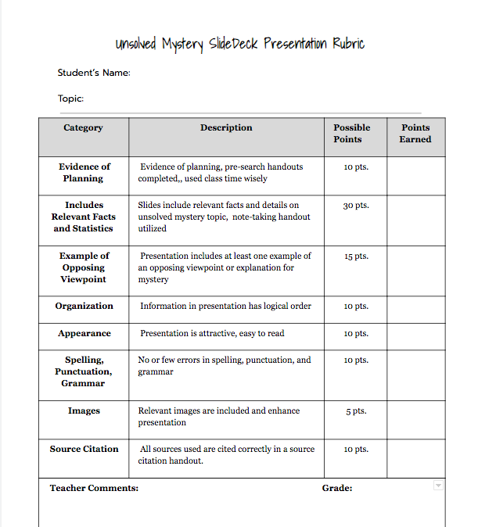

References:
Bybee, R.W. et al. (1989). Science and technology education for the elementary years: Frameworks for curriculum and instruction. Washington, D.C.: The National Center for Improving Instruction.
Bybee, R. W. (1997). Achieving Scientific Literacy: From Purposes to Practices. Oxford: Heinemann.
National Research Council. (1999). Inquiry and the national science education standards: A guide for teaching and learning. Washington, D.C.: National Academy Press.
Polman, J.L. (2000). Designing project-based silence: Connecting learners through guided inquiry. New York: Teachers College Press.

