University of West Alabama
5E Lesson Plan Template
Arctic Animal Research Project
Teacher: Heather Bozzelli
Date: 2/22/19
Subject area/course/grade level: Science/English Language Arts/2nd Grade
Materials: Pencils, research paper graphic organizers, vocabulary picture cards and definitions, Chromebooks/iPads, informational books/sources
Standards (State and ISTE Standards for Students):
State Standards:
Science:
7) Obtain information from literature and other media to illustrate that there are many different kinds of living things that they exist in different places on land and in water.
English Language Arts:
27) Participate in shared research and writing projects (e.g., read a number of books on a single topic to produce a report; record science observations). [W.2.7]
ISTE Standards:
1) Empowered Learner – Students leverage technology to take an active role in choosing, achieving and demonstrating competency in their learning goals, informed by the learning sciences.
6) Creative Communicator – Students communicate clearly and express themselves creatively for a variety of purposes using the platforms, tolls, styles, formats, and digital media appropriate to their goals.

Objectives:
- Students will be able to research to build and present knowledge to their intended audience.
- Students will be able to obtain information from various sources (Pebblego/Informational books) about arctic animals.
Differentiation Strategies (How will the lesson address the various learning styles of the students and the needs of those with special needs?):
The students will be exposed to various types of technology based on the needs of each student (Chromebooks/iPads). Students who struggle with the Chromebooks will have access to iPads and all activities we do online have an App the student can use.
The students will be with partners depending on their needs and abilities. However, the students must complete their own individual work.
The students will be given opportunities to practice through various activities.
It involves all learning types-kinesthetic, auditory, tactile, and visual.

ENGAGEMENT:
Questions: What do you know about the arctic habitat? What are some types of arctic animals?
- The teacher will discuss what the students already know about the arctic habitat and arctic animals by creating a KWL chart. During this time the students will be asked to copy down the KWL chart paper.
- After the students have called out what they already know, the teacher should ask what they want to know about the arctic habitat and animals. (What do you want to know about the arctic habitat? What types of arctic animals are you interested? Which animals do you think you would want to know more about?)
- After all of the questions have been asked and answered, the teacher will play the BrainPop Jr. video: Arctic Habitats https://jr.brainpop.com/science/habitats/arctichabitats/
- The teacher will play the YouTube video about arctic animals https://www.youtube.com/watch?v=3Wm1G1MBGh8
- After the students watch the videos, they will need to fill in what they learned about the arctic habitat and animals on their KWL chart. Then, we will have a discussion about some of the things the students learned and found interesting.
- The teacher will show the students some pictures of arctic animals and allow them to be thinking about what animal they may want to do research on. During this time, the students are asked to turn and talk to a partner about what animal they want to do their project on.
Assessment: The students will cut and sort pictures of arctic and not arctic animals on a chart. This will allow the teacher to understand if the students know the difference between arctic animals and not arctic animals for when they are choosing for their project.
EXPLORATION:
- The teacher will review with the students the different types of arctic animals they are able to research.
- The teacher will expose students to the different materials they are able to use while researching their animal:
- https://www.pebblego.com/choose
- https://jr.brainpop.com/science/
- Pebblego allows the students to explore different animals and their habitats, foods, life cycles, fun facts, and also provides related articles and videos. (Teacher will provide students with username and password).
- Brainpop Jr. allows the students to watch videos relating to the arctic habitat and animals. Students have the opportunity to take quizzes, play games, and complete activities on Brainpop Jr. (Teacher will provide students with username and password).
- While students are researching they will fill out a graphic organizer that consists of: animal appearance, habitat, food, life cycle, and interesting Facts.

Assessment: Students will take the (easy or hard) arctic habitat quiz on Brainpop Jr. and submit it to the teacher online. https://jr.brainpop.com/science/habitats/arctichabitats/easyquiz/
EXPLANATION:
- Teacher will review important vocabulary with students by using vocabulary picture word cards and definitions. (Predator, prey, tundra, arctic, hibernate, migrate, adapt).
- In small groups, students will match the correct vocabulary picture to its definition.
- Teacher will pull the students back into whole group to review the cards and make sure all students understand the vocabulary.
- The teacher will make sure each student understands about arctic habitats and animals that live in that habitat.
- During this time, the teacher will also explain that the students are going to use the information they have researched to create their own Blabberize on the Chromebooks.

Assessment: Students will then be provided with the “Arctic 3,2,1” graphic organizer that consists of: Three facts they learned, two new vocabulary words and definitions, one question they still may have.

ELABORATION:
- The teacher will review what the students have learned and introduce what the students will be doing with their information – Creating a Blabberize (Individual Project)
- Teacher example, Polar Bears: http://blabberize.com/view/id/1833773
- Other Examples: https://www.youtube.com/watch?v=PB_bFwFw_2k
- The teacher will provide the students with the login and password to have access to the assignment on the teacher’s account on Blabberize.
- Teacher will pass out the rubric for this individual assignment, and explain to students that they are to meet the criteria for each section of the rubric. The students will be with partners depending on their needs and abilities. However, the students must complete their own individual work.
- Teacher will tell students to use creative ideas when creating the Blabberize for each arctic animal.
- The students should have their research facts and information for this project. They will use a Chromebook to complete this assignment. (Or an iPad if given permission).
- Once students are finished, they will have time to share with partners around the room.
- Students should share this assignment by writing down the name of their Blabberize and turning it in.
Assessment: Students will turn in their facts graphic organizers and Blabberize project.
EVALUATION:

Rubric for Individual Project: Created with Rubistar.com

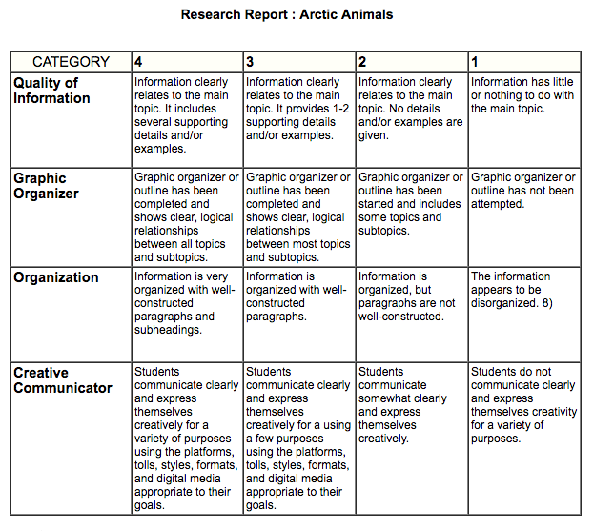

References:
Bybee, R.W. et al. (1989). Science and technology education for the elementary years: Frameworks for curriculum and instruction. Washington, D.C.: The National Center for Improving Instruction.
Bybee, R. W. (1997). Achieving Scientific Literacy: From Purposes to Practices. Oxford: Heinemann.
National Research Council. (1999). Inquiry and the national science education standards: A guide for teaching and learning. Washington, D.C.: National Academy Press.
Polman, J.L. (2000). Designing project-based silence: Connecting learners through guided inquiry. New York: Teachers College Press.

