Pepitos
(Roasted Pumpkin Seeds)
Pumpkin seeds
Butter
Garlic butter

After taking the pumpkin seeds out of the pumpkin, clean them, and let them dry. Sauté the seeds in butter, then put them on parchment paper on a cooking sheet. Preheat the oven to 350 degrees. Sprinkle the seeds with garlic butter. Bake the pumpkin seeds until light brown. (I baked them 10 minutes at a time; about 25 minutes.) Enjoy!
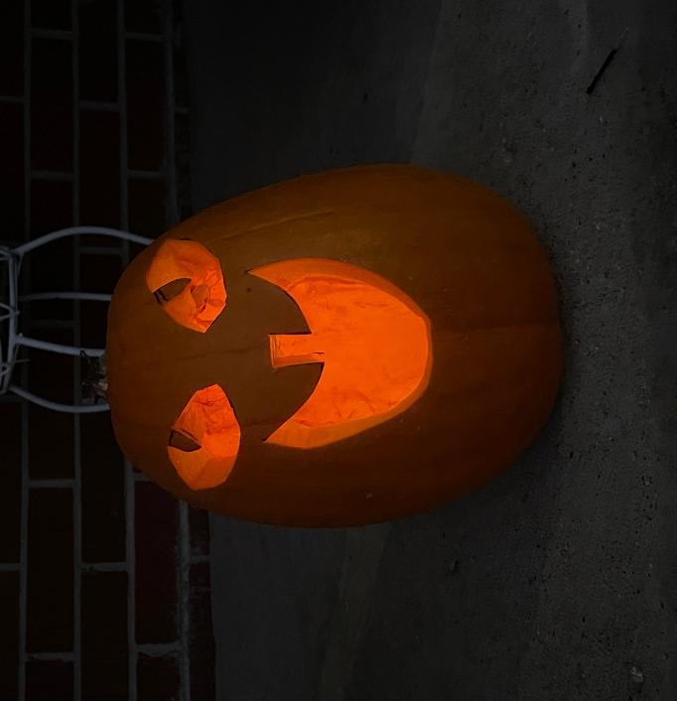
The FFA gave us a pumpkin, and we completed a booklet with information about the pumpkin. We found out that it does float, and this pumpkin had 394 seeds. We tried them, and most students liked them! (Everyone tried them. )

