AP U.S. Government
Unit 5 Exam – Legislative Branch/Economic Policy & Budget
(Version B)

1. What have reformers proposed to increase turnover in the membership of Congress?

- Term limits
- Credit claiming
- Franking privileges
- Incumbency

2. Of the following groups, which is most underrepresented in Congress?

- African Americans
- Whites
- Hispanics
- Women

3. What is the vice president’s only constitutionally defined job?

- To look after the “Good and the Welfare of We the People”
- To represent the president at official state functions
- To preside over the Electoral College
- To serve as president of the Senate

4. In the House of Representatives, the ______ controls the scheduling of bills for debate.

- House Ways and Means Committee
- Speaker of the House
- House Rules Committee
- Chief Administrative Officer

Use the graph below for questions 5-6
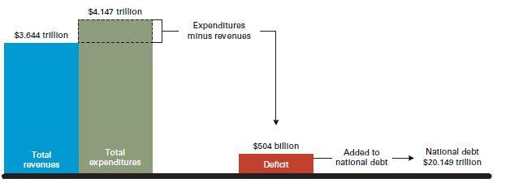

5. Based on the graph, what is a budget deficit?

- The amount the nation owes to other countries
- The difference when expenditures exceed revenues
- The cost of social services the government offers
- The money the government has left to spend at the end of the year

6. When does a balanced budget occur?

- Appropriations are equal to authorizations
- Government spending is equal to the sum of all tax expenditures
- The national debt is zero
- There is no budget deficit

7. Nominees to the US Supreme Court must be confirmed by

- The Senate
- The House
- Either House or Senate
- The President

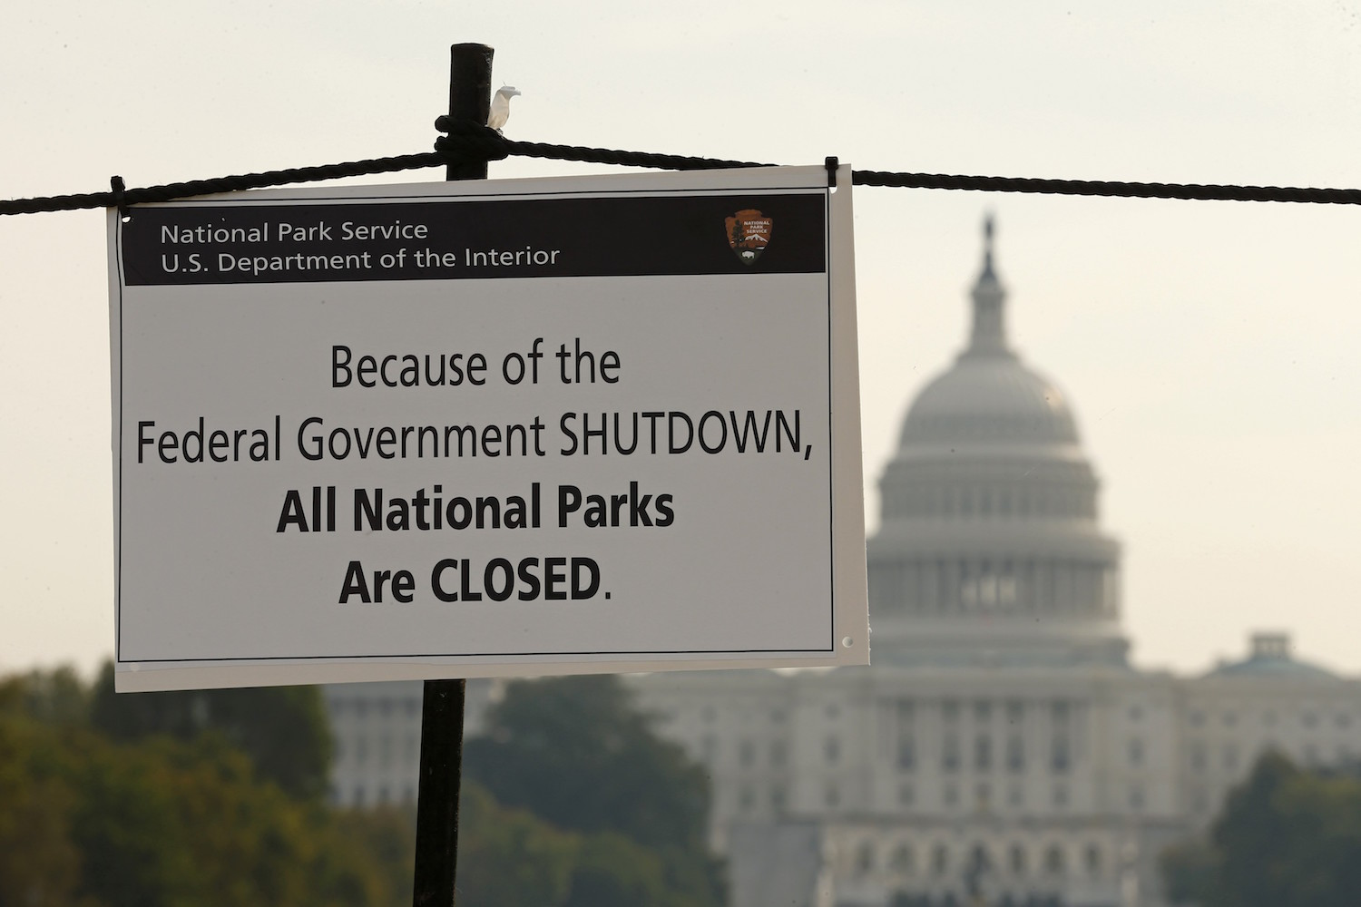

8. Which of the following situations might have contributed to the situation pictured?

- The rising national debt led to severe cuts in government spending
- The federal government shut down parks to preserve the environment
- The Office of Management and Budget neglected to give money to the parks
- Congress and the president could not compromise, leading to a shutdown

9. The 16th Amendment, ratified in 1913

- Explicitly permitted Congress to levy an income tax
- Forbade Congress from levying an income tax, but was later repealed
- Limited the total income tax Congress could levy on an individual
- Required the federal government to balance the budget each year until the Great Depression.

10. What is the national debt?

- All of the money Congress has spent
- All of the money the federal government has borrowed and has not yet repaid
- The sum of all tax expenditures minus the sum of all tax receipts
- The sum of all tax receipts minus the sum of all tax expenditures

11. When does a surplus occur?

- When revenues in a given year exceed expenditures
- When expenditures in a given year exceed revenues
- When income tax revenues exceed the revenues from excise taxes
- When the government has excess funds because the national debt has been eliminated

12. All of the following are responsibilities of the Federal Reserve Board EXCEPT

- Buying and selling federal government securities
- Regulating the amount of money a member bank must keep on hand as reserve
- Reviewing the federal budget and making recommendations to prevent deficits
- Changing the interest rates charged to banks that borrow from the FED.

13. Which of the following best describes Keynesian economic theory?

- Controlling the money supply to control the economy
- Using deficit spending to combat an economic slump
- Using tax cuts to stimulate economic growth
- Reducing the number of government regulations on business to stimulate economic growth

14. Approximately what percentage of the federal budget is uncontrollable?

- One-third
- One-half
- Two-thirds
- One-fourth

15. Which of the following best describes the federal budget?

- It is a document that announces how much the government expects to collect in taxes and how expenditures will be allocated on various programs
- It is a document that just predicts a bottom line, including the dollar amount of a projected surplus or deficit
- It is a document that describes the federal debt and proposes a payment plan
- It is a document that changes over the course of a year, as revenue and expenditures change with the times

16. The ultimate power to determine how much the government will tax and spend; and what will it spend taxes for lies with

- The President
- Congress
- The courts
- The Treasury Department.

17. What is the relationship between voting behavior and economic conditions?

- People who are unemployed are less likely to vote for an incumbent, but voting behavior and economic conditions are not correlated for those who have jobs
- There is a strong correlation between economic conditions and voting behavior, where people are less likely to vote for incumbents in poor economic times
- Most voters do not believe that the president has much impact on economic conditions, so there is little correlation between voting behavior and the economy
- In poor economic times, incumbents are more likely to be reelected because the public is hesitant to change leadership in hard times

18. Which of the following is an accurate comparison of the House of Representatives and the Senate?

 | House of Representatives | Senate
A | Only the Speaker of the House can initiate the legislative process by proposing bills | Only the majority leader can initiate the legislative process by proposing bills
B | Members can delay the policy-making process by invoking cloture | Members can delay the policy-making process through the use of a filibuster
C | Members are elected by constituents in a local district based on population | Members are elected by constituents of an entire state
D | Members must be natural born citizens | It doesn’t matter if members are natural born citizens

19. Which of the following is an accurate comparison of the House of Representatives and the Senate?
 | House of Representatives | Senate
A | Allows filibusters until a majority vote defeats the filibuster | Is a 101-member body, as the Vice president can vote on all bills
B | Has committees chaired by members in the minority | Is first in the lawmaking process when it comes to tax law
C | Has more rules of procedure to guide its lawmaking process | Has authority over the ratification of treaties with other nations
D | Is solely in charge of declaring war | Has the sole power of impeachment

20. Which of the following is an accurate comparison of the House of Representatives and the Senate?

 | House of Representatives | Senate
A | Members represent individual districts throughout the states | Members are appointed by their state legislature
B | 435 voting members | All appropriations bills must begin here
C | Confirm presidential appointments | Ratify presidential treaties
D | Members must be at least 25 years of age to serve in the chamber | Members must be at least 30 years of age to serve in the chamber

21. Which of the following is an accurate comparison of the House of Representatives and the Senate?

 | House of Representatives | Senate
A | 100 members in the chamber | 435 members in the chamber
B | Speaker of the House is the presiding officer | The Majority leader is the most influential leader and party spokesman
C | All appropriations bills must begin here | Contains the Rules Committee
D | Members were originally chosen by state legislatures | Confirm court nominees

22. Which of the following is an accurate comparison of the House of Representatives and the Senate?

 | House of Representatives | Senate
A | All appropriations bills must begin here | Have the power to filibuster
B | Headed by the Vice President | 100 members
C | Contains a Rules Committee | Members are elected in individual districts
D | Members must be at least 30 years of age to serve in the chamber | Members must be at least 35 years of age to serve in the chamber

23. According to the Constitution, once impeached, federal officials are then tried in the

- Supreme Court
- House
- Senate
- U.S. District Court for the District of Columbia.

24. Legislative _____ is the process of monitoring the bureaucracy and its administration of policy.

- Apportionment
- Overview
- Supremacy
- Oversight

25. In Shaw v. Reno (1993) the U.S. Supreme Court held that ______________

- Efforts to construct political districts on the basis of the racial characteristics of voters violated the 15th Amendment
- Efforts to construct political districts on the basis of the racial characteristics of voters were no different in principle than efforts to construct political districts on the basis of other characteristics of voters and thus did not violate the equal protection clause
- Racial gerrymanders were constitutional only if they were narrowly tailored to serve compelling ends, such as compliance with the Voting Rights Act
- Efforts to ensure that historically discriminated groups can become majority voters in certain districts cannot be viewed as unconstitutional discrimination

26. Which of the following is not a step that a proposed bill would encounter on its journey through Congress?

- The bill is debated
- The bill is introduced by a member of the executive department
- The bill is voted on, at which time it may pass or be defeated
- The bill may be assigned to a subcommittee

27. A member of the House of Representatives who wishes to be influential in the House itself would most likely seek a place on which of the following committees?

- Agriculture
- Rules
- Transportation and Infrastructure
- Veteran’s Affairs

28. Which of the following is NOT true of the Congress

- Each house determines its own leadership and rules
- Terms in the HOR last for two years
- Congress is unicameral in nature
- A session of Congress begins on January 3 of odd-numbered years.

29. In order of decreasing amounts, federal expenditures include

- National defense, interest on the national debt, direct payments to individuals, and state and local grants
- Direct payments to individuals, national defense, interest on the national debt, and state and local grants
- Interest on the national debt, national defense, direct payments to individuals, and sate and local grants
- National defense, direct payments to individuals, state and local grants, and interest on the national debt

30. Social Security payments are an example of a (n)

- Increment
- Entitlement
- Controllable expenditure
- Grant

31. Enumerated powers given to Congress in the Constitution include all of the following EXCEPT

- Override Supreme Court opinions
- Declare war
- Collect taxes
- Regulate interstate commerce

32. What is true of all REVENUE bills in Congress?

- Pass without the consent of the president
- Must be introduced by the majority party
- Must be introduced in the House
- Must originate in the Senate finance committee

33. This type of committee reconciles differences between House and Senate bills before they are sent to the president for signing

- Select committee
- Standing committee
- Conference committee
- Committee of the whole

34. Members of Congress have many different duties and responsibilities. When Tom takes time during his days in Congress to help someone back home that is struggling with his or her Passport application he is performing this duty

- Making laws
- Oversight
- Constituent service (case work)
- Partisan leader

35. All of the following is true about the House of Representatives EXCEPT

- 435 members
- Serve for six-year terms
- Directly elected by the people
- Tends to be more responsive to localized issues

36. Which of the following determines who holds the leadership positions in Congress?

- Majority party
- Tenure in office
- Bipartisan vote
- Presidential appointment

37. After years of serving in the House Frank was given the responsibility of informally vote counting in the House of Representatives. This duty also involved attempting to sway votes in favor of Frank’s party position. What title is given to Frank’s work?

- Speaker
- Majority Leader
- Majority Whip
- Minority Leader

38. In recent years, according to public opinion polls, Congressional approval ratings have tended to be

- Higher than 80%
- Between 50 – 75%
- Between 25 – 50%
- Lower than 25%

39. When the House of Representatives reapportions it

- Re-calculates the number of Districts each state receives
- Counts the number of Democrats and Republicans serving
- Counts the number of females and minorities serving
- Re-calculates the money it provides to each state

40. In this court case it was ruled that Congressional Districts were in the purview of Court action. Having now entered into the political thicket, the Court soon would rule the “one man one vote” standard. That is, each Congressional District must have the same population. This case advanced the civil rights movement.

- NLRB v. Jones (1937)
- Brown v. Board of Education (1954)
- Baker v. Carr (1962)
- Miranda v. Arizona (1966)

41. Which example best demonstrates a legislator acting as a trustee of his or her constituency?

- A legislator uses his or her best judgment
- A legislator does whatever is best for his or her reelection
- A legislator follows the public opinion of his or her constituency
- A legislator does what is in the best interest of his or her party

42. Nancy takes every vote in Congress seriously. She also worries about her reelection. Most of her votes are cast to represent as best as she can her constituents back home. What type of Congressional voter is she?

- Delegate
- Trustee
- Partisan
- Politico

43. Articles of Impeachment must be passed by

- Either the House or the Senate
- The Supreme Court
- The Senate
- The House

For questions 44 and 45 refer to the following graph

The Incumbency Factor in Congressional Elections

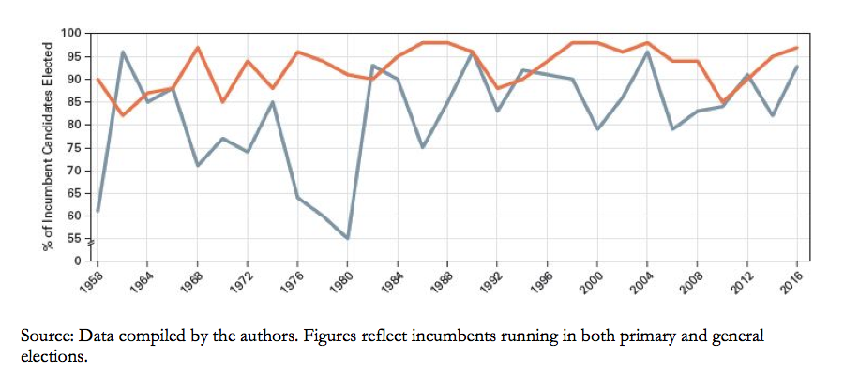

44. Based on the graph, which statement about incumbency is most accurate?

- Incumbents have a significant reelection advantage
- Incumbents are prohibited from accepting campaign contributions from interest group members
- Incumbents only leave office when pressured by party leadership
- Incumbents often leave office at the end of their term

45. Which of the following, which might include federal spending projects, might contribute to the trend indicated in the graph?

- Apportionment
- Casework
- The pork barrel
- Logrolling

46. To be sent to the President, a bill must be passed by

- The House
- The Senate
- Either the House or the Senate
- Both the House and the Senate

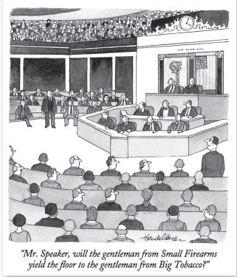

47. Using the image above, which of the following is the cartoonist’s main argument?

- Congressmen have a diverse set of interests to represent
- Interest groups play too big a role in policy making
- More lobbyists have been elected to Congress than ever before
- Interest groups only represent controversial issues

48. Who is second in authority to the Speaker of the House in the House of Representative?

- Majority leader
- Majority whip
- Minority leader
- President pro tempore

49. How might the pork barrel aid a congressional member’s district?

- Diverting unallocated funds to another government agency
- Increasing jobs and revenue with federally funded projects
- Increasing revenue through private market investment
- Taxing corporations less so they provide health insurance for employees

Question 50-51 refer to the passage below

“Every bill which shall have passed the House of Representatives and the Senate, shall, before it become a law, be presented to the President of the United States; if he approve he shall sign it, but if not he shall return it, with his objections to that House in which it shall have originated, who shall… proceed to reconsider it. If after such reconsideration two thirds of that House shall agree to pass the bill, it shall be sent, together with the objections, to the other House, by which it shall likewise be reconsidered, and if approved by two thirds of that House, it shall become a law…. If any bill shall not be returned by the President within ten days (Sundays excepted) after it shall have been presented to him, the same shall be a law, in like manner as if he had signed it…”
--Article I, Section 7, U.S. Constitution, 1787

50. According to the Constitution, how can a bill become a law without the president’s signature?

- The Vice President can sign it as the president of the Senate
- Congress can override the veto with a 2/3 vote in both houses
- Congress can demand a bill become a law if a majority of both houses voted for it
- Congressional committees can sign bills into law

51. How does Article I, Section 7 exemplify the concept of checks and balances?

- Congress does not need to involve other branches in lawmaking
- States, through their congressional representatives, are involved in lawmaking
- The Constitution mandates that Congress establish committees
- No one branch is single handedly in control of making laws for the country

52. How can a filibuster can be ended?

- Abrogation supported by fifty-one senators
- Censure voted on by fifty-five senators
- Cloture approved by sixty senators
- Discharge voted on by sixty-seven senators

53. Temporary committees appointed for the specific purpose of investigating a particular issue are called

- Joint committees
- Select committees
- Standing committees
- Investigating committees

54. Which of the following makes economic projections about the performance of the economy, the costs of proposed policies, and the economic effects of taxing and spending alternatives?

- Congressional Budget Office
- Rules Committee
- House Ways and Means Committee
- Senate Finance Committee

55. Where does most of Congress’s work happen?

- Recess
- Committees
- Conferences
- Hearings

Key

- A
- D
- D
- C
- B
- D
- A
- D
- A
- B
- A
- C
- B
- A
- A
- B
- B
- C
- C
- D
- B
- A
- C
- D
- B
- B
- B
- C
- B
- B
- A
- C
- C
- C
- B
- A
- C
- D
- A
- C
- A
- A
- D
- A
- C
- A
- B
- A
- B
- B
- D
- C
- B
- A
- B

