Elastic Collisions
Purpose: To gather evidence that can be used to support a claim that total system momentum is or is not conserved in an elastic collision.
Background: The objects involved in a collision are often considered as a system. Provided that the system of two objects is not experiencing a net external impulse, there would be no change in momentum of the system. If one object within the system loses momentum, it is gained by the other object within the system. The combined momentum of both objects would be conserved.
Getting Ready: Navigate to the Collision Carts Interactive in the Physics Interactives section of The Physics Classroom website:
http://www.physicsclassroom.com/Physics-Interactives/Momentum-and-Collisions/Collision-Carts Path:
physicsclassroom.com => Physics Interactives => Momentum and Collisions => Collision Carts
Once the Interactive opens, resize it as desired. Select the Elastic Collisions option. Experiment with changing the Mass and the Initial Velocity of the two carts. Observe how the position of the carts along the track can be changed by dragging. Learn to Start, Pause, and Reset the animation.

Collision 1: Blue Cart Initially at Rest
Set the initial blue cart velocity to 0 m/s. Set the mass values to different values. Run the simulation and record the mass and velocity values.

Before Collision After Collision
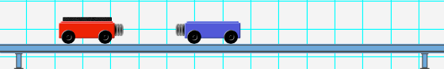
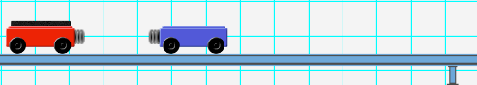
v_{red} = m/s v_{red} = m/s v_{blue} = m/s

m_{Red} = kg m_{Blue} = kg

Use mass and velocity values to complete the following momentum table.

 | Before Collision | After Collision | ∆Momentum
Red Cart | kg x m/s  = kg•m/s | kg x m/s  = kg•m/s
Blue Cart | kg x m/s  = kg•m/s | kg x m/s  = kg•m/s
System Total

Collision 2: Blue Cart Moving Slower than the Red Cart
Set the initial blue cart velocity to less than the red cart velocity. Position the blue cart near the red cart so that the collision occurs near the middle of the track. Give the blue cart a smaller mass. Run the simulation and record the post-collision mass and velocity values.

Before Collision After Collision

v_{red} = m/s
v_{blue} = m/s
v_{red} = m/s v_{blue} = m/s

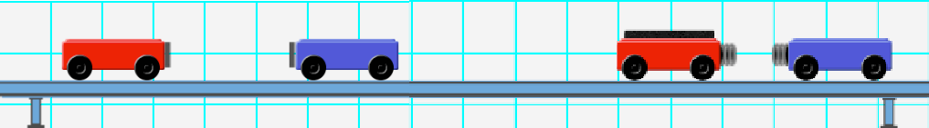

m_{Red} = kg m_{Blue} = kg
Use mass and velocity values to complete the following momentum table.

 | Before Collision | After Collision | ∆Momentum
Red Cart | kg x m/s  = kg•m/s | kg x m/s  = kg•m/s
Blue Cart | kg x m/s  = kg•m/s | kg x m/s  = kg•m/s
System Total

Conclusion
Make a Claim as to whether momentum is conserved or not conserved. Identify the Evidence that supports your claim; refer to specific sets of values in each data table. Write a paragraph or more of sound Reasoning to argue why the evidence logically lead to the claim you are making. Write well. Write logically. Write thoroughly. Use a separate page of paper if necessary.

