Optics Bench – Curved Mirror Image Characteristics

Purpose: To investigate the effect of varying object location upon the characteristics of the images formed by a concave and a convex mirror.

Getting Ready: Navigate to the Optics Bench simulation found in the Physics Interactives
section of The Physics Classroom.
http://www.physicsclassroom.com/Physics-Interactives/Reflection-and-Mirrors/Optics-Bench Navigation:
www.physicsclassroom.com => Physics Interactives => Reflection and Mirrors => Optics Bench

Getting Acquainted:
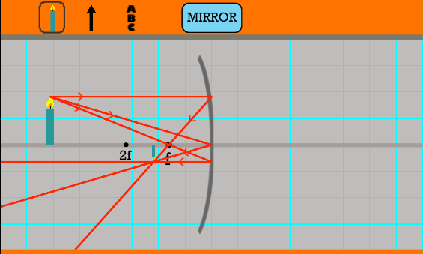
By default, Optics Bench opens in Lens mode. Click on the Lens button to change to Mirror mode. You should observe a curved mirror with its principal axis, a candle, and three sets of incident and reflected rays. See diagram. Experiment with the environment in the following ways:
- Tap and drag the candle back and forth along the axis; observe how the image changes.
- Use the focus slider to change the focal length. Notice how f and 2f change location. The 2f point is the Center of Curvature location.
- Use the height slider to change the image height.
- Notice how the object can be changed into an arrow or a vertical column of letters (A B C).
- Notice how the incident rays can be toggled ON and OFF.
- Notice how the object can be dragged to the right side of the mirror – the convex side.

Observations:
- Concave Mirrors: Use the sliders to set the focal length to approximately 30 cm and the object height to approximately 20 cm. Then drag the sliders to the various locations described in Table 1. For each location, practice the L•O•S•T art of image description - that is, describe the image Location, Orientation, Size, and Type. Record your observations using Table 1 on the reverse side by circling the appropriate descriptor.

- Convex Mirrors: Use same values of focal length and object height. Drag the object to the right side of the mirror and observe the image. The right side of the mirror is the convex side. Do the basic characteristics of the image depend upon where on the right side of the mirror that the object is placed? Experiment to find out. Practice the same L•O•S•T art of image description for a nearby and distant object position. Record your observations using Table 2 on the reverse side by circling the appropriate descriptor.

Table 1 - Concave Mirror
 | L•O•S•T art of Image Description
Object Position | Location | Orientation | Size | Type*
Beyond or Behind C (more than 2f from the mirror) | At C (or 2F) Beyond or Behind C Between C and F  Behind the mirror | Upright Inverted | Magnified Same Size Reduced | Real Virtual
At C  (a.k.a., at 2f) | At C (or 2F) Beyond or Behind C Between C and F  Behind the mirror | Upright Inverted | Magnified Same Size Reduced | Real Virtual
Between C and F (more than 1f from the mirror; less than 2f) | At C (or 2F) Beyond or Behind C Between C and F  Behind the mirror | Upright Inverted | Magnified Same Size Reduced | Real Virtual
In front of F  (less then 1f from the mirror) | At C (or 2F) Beyond or Behind C Between C and F  Behind the mirror | Upright Inverted | Magnified Same Size Reduced | Real Virtual
* Real images are formed when reflected light rays converge at the image location. Virtual images are formed when light rays diverge after reflection.

Table 2 - Convex Mirrors
 | L•O•S•T art of Image Description
Object Position | Location | Orientation | Size | Type
Nearby Position (more than 2f from the mirror) | At C (or 2F) Beyond or Behind C Between C and F  Between F and mirror | Upright Inverted | Magnified Same Size Reduced | Real Virtual
Distant Position  (a.k.a., at 2f) | At C (or 2F) Beyond or Behind C Between C and F  Between F and mirror | Upright Inverted | Magnified Same Size Reduced | Real Virtual

