Mrs. Holodick

6th Grade Social Studies

Room #3

Name: __________________________

Period: ________

Chapter 7

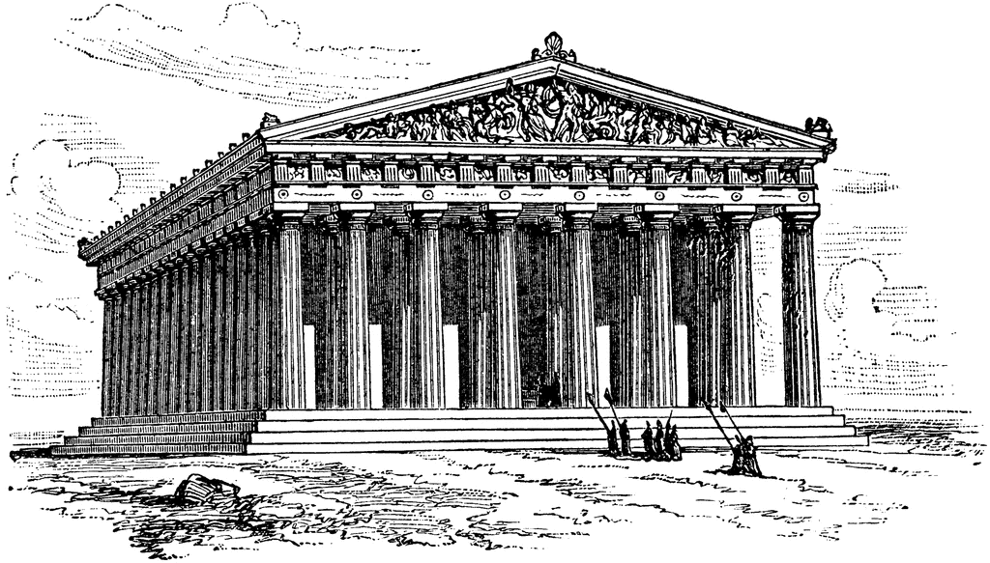

The Glory of Ancient Greece

Chapter 7: The Glory of Ancient Greece

* Level 1 assignments are required for all classes (everyone)
* Level 2 assignments are required for honors classes, but optional for non-honors classes. If completed, They will be counted as extra credit for non-honors
* Level 3 Assignments are optional, but will be counted as extra credit if completed.
* Any extra credit assignments will not be counted unless all required work is completed
* Packet points will be added up and divided into the total number available. The percentage will be counted as a test grade.

Level 1 Assignments: All Level 1 Assignments Are Required For Everyone!! (100 Total Points Available)

1. ________/10 Points: Glory of Ancient Greece Timeline Due Date___________- Page 3

2. ________/15 Points: Glory of Ancient Greece Vocabulary Due Date___________- Pages 4-5

3. ________/10 Points: Section 1 Notes Due Date __________ - Pages 5-6

4. ________/15 Points: Section 1 Guided Reading & Review Due Date __________ - Pages 7-8

5. ________/10 Points: Section 2 Notes Due Date __________ - Page 9

6. ________/15 Points: Section 2 Guided Reading & Review Due Date __________ - Pages 10-11

7. ________/10 Points: Section 3 Notes Due Date __________ - Page 12

8. ________/15 Points: Section 3 Guided Reading & Review Due Date __________ - Pages 13-14

Level 2 Assignments: Required For Honors, Optional for Non-Honors Students (10 Total Points Available)

1. ________/10 Points: Spartan Hoplite Shield Project (Directions on Pages 15-17)

Level 3 Assignments: These assignments are optional, but if completed will count as extra credit toward your total point value. Will only be counted if Level 1 and 2 assignments are completed (20 Total Points Available)

1. ________/20 Points: Ancient Greece Lapbook Project (Directions on Pages 18-19)

Glory of Greece Timeline

***Directions:*** Timelines are a visual way of showing the order in which events took place. They are a way of placing them in chronological order (the order in which they occurred). Timelines help us make sense of a number of events of the past. They help us see how one event might relate to others. Note that all dates are approximate. Use this timeline to answer the questions below.

Alexander, who had conquered Persia, Egypt, and lands beyond the Indus River, dies in Babylon

Sparta and its allies fight against Athens and its allies in the Peloponnesian War

Athenians defeat a much larger Persian army at the Battle of Marathon

Wars inside and outside the city-state of Sparta turn it into a war machine

King Phillip of Macedonia gains control of all of Greece

**600B.C 520B.C 490B.C 480B.C 431B.C. 404B.C 338B.C. 336B.C. 323B.C. 300B.C 0 00- 2300B.C. 1787B.C 1200B.C. 722B.C. 650B.C 612B.C. 539B.C. 490B.C. 0**

300 Spartans allied with other Greek city-states defend a narrow pass at Thermopylae against the Persians

Euclid, a mathematician, develops the branch of Mathematics called geometry during the Hellenistic Age

King Phillip is assassinated and his son Alexander becomes king of Macedonia and Greece at the age of 20

Athens surrenders to Sparta ending the Peloponnesian War and Athens dominance of the Greek world

The Persians gain control of Greek city-states on the West coast of Asia Minor

1. What is the date and event we will start our studies of the Glory of Greece on? _____________________

___________________________________________________________________________________________

1. How many years will our studies span? _______________________________________________________
2. In what year were the Greeks conquered? ______________________________________________________
3. Between what years was the Peloponnesian War? _______________________________________________
4. Pick an event on the timeline that you seem most interested in. What is it and why are you interested?

__________________________________________________________________________________________

__________________________________________________________________________________________

**Vocabulary**



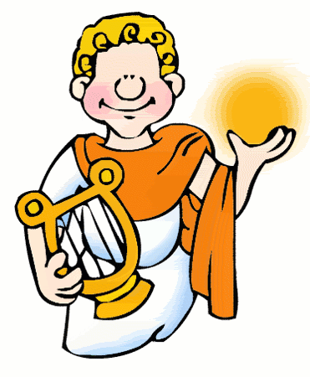

**Chapter 7: The Glory of Ancient Greece**

Section 1: ***Daily Life In Athens***

**Athens - ________________________________________________________________________________**

**________________________________________________________________________________________**

**Agora - _________________________________________________________________________________**

**________________________________________________________________________________________**

**Vendor - ________________________________________________________________________________**

**________________________________________________________________________________________**

**Slavery - ______________________________________________________________________________**

**________________________________________________________________________________________**

Section 2: ***Athens and Sparta***

**Sparta** - _________________________________________________________________________________

________________________________________________________________________________________

**Helots- _________________________________________________________________________________**

**________________________________________________________________________________________**

**Peloponnesian War -______________________________________________________________________**

**________________________________________________________________________________________**

**________________________________________________________________________________________**

**Plague - _________________________________________________________________________________**

**________________________________________________________________________________________**

**Blockade - ______________________________________________________________________________**

**________________________________________________________________________________________**

Section 3: ***The Spread of Greek Culture***

**Barbarian** - ______________________________________________________________________________

________________________________________________________________________________________

**Assassinate-______________________________________________________________________________**

**________________________________________________________________________________________**

**Alexander the Great -______________________________________________________________________**

**________________________________________________________________________________________**

**Hellenistic- ______________________________________________________________________________**

**________________________________________________________________________________________**

**________________________________________________________________________________________**

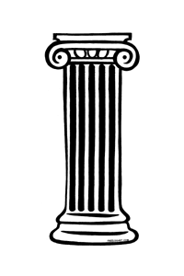



3

2

1

4

5

6

8

7

9

After the Persians arrived at the pass, several days crept by without battle beginning. Xerxes sent a scout to find out what the Greek position was. The scout returned to the king, who was amazed by what he heard. In front of a wall that blocked the pass the 300 Spartans were combing their hair and exercising. However, the king was warned not to misread this information: the Spartans were preparing to fight to the death and were men of great bravery.

10

11

12

Complete Using Vocabulary Terms

**Across**

1. Wide Spread disease
2. To cut off enemy supplies

**5**. A wild or uncivilized person

**6**. You would see this people selling goods in the Agora in Ancient Greece

**9**. Where goods would be bought in Ancient Greece

1. He conquered Persia and Egypt. There is a city in Egypt named after him
2. Slaves who were owned by the State

**Down**

**1.** Athens V. Sparta (and just about every other GreekCity state)

**3**. To murder a political leader

**4**. Being forced to work for someone else

**7**. Greek time period after Alexander the Great

**8**. Home of the Spartans

**10.** Home of the Parthenon; Capital of Modern Day Greece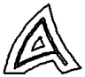

DAILY LIFE IN ANCIENT Athens

Life at Home

Slavery

The Marketplace

**Daily Life in Athens**

**Chapter 7, Section 1**

**Directions: Using class discussions and your textbook pages 198-203, fill in the blanks with the correct information**

**Critical Thinking Questions:**

1. Describe the daily life of a boy from Athens __________________________________________

_______________________________________________________________________________

_______________________________________________________________________________

_______________________________________________________________________________

2. In Athens, only ____________ were active in public life.

3. What did Athenian boys look forward to _____________________________________________

_______________________________________________________________________________

4. The Acropolis was the center of Athens’ _______________________ and the Agora was the

center of its ______________________________.

5. What is the Agora? _____________________________________________________________

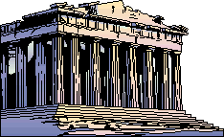

6. Describe the activities of the Agora _______________________________

_____________________________________________________________

7. What kind of goods could you find at the Agora? ______________________________________

_______________________________________________________________________________

8. Describe the public buildings of Ancient Greece _______________________________________

_______________________________________________________________________________

9. Describe a typical house of Greece (What did it look like)? ______________________________

_______________________________________________________________________________

_______________________________________________________________________________

10. What was one luxury that some homes had, but most did not?___________________________

11. Where did Greeks have to go for this luxury? ________________________________________



12. Meals in ancient Greece were simple just like the homes. List what people would eat for

Breakfast. ______________________________________________________________________

13. What about Lunch? ____________________________________________________________

14. How about Dinner? ____________________________________________________________

15. Most of the people you would see in the agora would be _______________________________

16. Where most of the Athenian women spend their days? ________________________________

17. What were Athenian women NOT allowed to do?

a) _________________________________________________________________________

b) _________________________________________________________________________

c) _________________________________________________________________________

18. What was the role of the women of Greece? ________________________________________

_______________________________________________________________________________

_______________________________________________________________________________

19. It is estimated that about how many slaves lived in Athens? ____________________________

20. This means about _____________________________ of the population of Athens were slaves.

21. Who were the slaves of Greece? _________________________________________________

_______________________________________________________________________________

22. Slaves were not considered ____________________________

23. How could slaves become free? __________________________________________________

_______________________________________________________________________________

24. List 5 duties of Slaves in Greece

a) _________________________________________________________________________

b) _________________________________________________________________________

c) _________________________________________________________________________

d) _________________________________________________________________________

e) _________________________________________________________________________

25. Most Greek households could not have operated without ______________________________

**Athens and Sparta Notes**



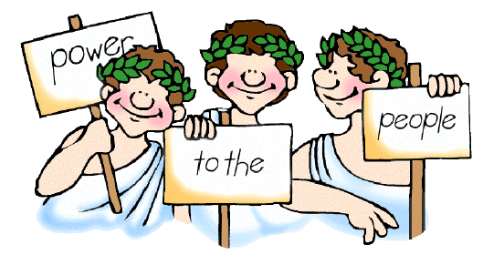

**Athens & Sparta**

**Chapter 7, Section 2**

**Directions: Using class discussions and your textbook pages 206-213, fill in the blanks with the correct information**

**Critical Thinking Questions:**

1. What does the Spartan story of the Boy and the Fox tell us about the people of Sparta? _______

_______________________________________________________________________________

_______________________________________________________________________________

2. Describe life in Sparta and the Spartans themselves ___________________________________

_______________________________________________________________________________

3. What happened in the 600s B.C. in Sparta? __________________________________________

_______________________________________________________________________________

4. What happened to the people the Spartans conquered? ________________________________

_______________________________________________________________________________

5. From birth, the life of every Spartan was in the hands of the _____________________________

6. Describe in detail, the life of a Spartan boy ___________________________________________

_______________________________________________________________________________

_______________________________________________________________________________

_______________________________________________________________________________

7. Describe in detail, the life of a Spartan girl ___________________________________________

_______________________________________________________________________________

_______________________________________________________________________________

_______________________________________________________________________________

8. What was the Spartan attitude toward trade? _________________________________________

_______________________________________________________________________________

9. What was the Spartan attitude toward the Arts? _______________________________________

_______________________________________________________________________________

10. Who did the Spartans fight against during the Greek Wars? ____________________________

11. By 250B.C. the __________________ had gained control of Greek colonies in Asia Minor.

12. What happened in Marathon in 490B.C? ___________________________________________

_______________________________________________________________________________

_______________________________________________________________________________

13. After the wars with Persia, what was the most powerful Greek city-state?__________________

14. Athens and other city states joined together to form ___________________________________

15. What were the years following the Persian Wars known as _____________________________

_______________________________________________________________________________

16. What happened that allies of Athens became angered and went to War with them? __________

_______________________________________________________________________________

_______________________________________________________________________________

17. Who did other Greek city-states look to for help against Athens? _________________________

18. What happened in 431B.C? _____________________________________________________

_______________________________________________________________________________

19. Who won the Peloponnesian War? Describe Why and How? ____________________________

_______________________________________________________________________________

_______________________________________________________________________________

_______________________________________________________________________________

20. Describe the Fall of Athens ______________________________________________________

_______________________________________________________________________________

_______________________________________________________________________________

_______________________________________________________________________________

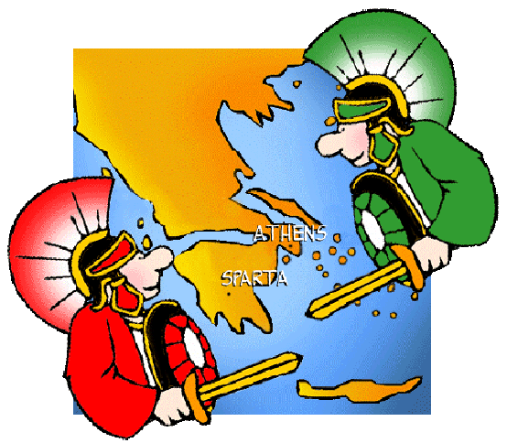

The Spread of Greek Culture

**The Hellenistic Age**

**Alexander’s Empire**

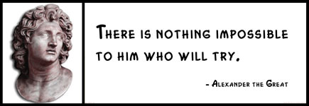

**The Spread of Greek Culture**

**Chapter 7, Section 3**

**Directions: Using class discussions and your textbook pages 216-222, fill in the blanks with the correct information**

**Critical Thinking Questions:**

1. Describe Alexander as a Boy _____________________________________________________

_______________________________________________________________________________

2. Where was Alexander from? _____________________________________________________

3. What did the Greeks think of the Macedonians? _______________________________________

_______________________________________________________________________________

4. Who was Aristotle? _____________________________________________________________

5. What did Aristotle do for Alexander? ________________________________________________

_______________________________________________________________________________

6. Who was Achilles? _____________________________________________________________

7. What was Phillips dream? ________________________________________________________

8. What were King Phillips Achievements? _____________________________________________

_______________________________________________________________________________

_______________________________________________________________________________

9. Who was Demosthenes and what did he do? ________________________________________

_______________________________________________________________________________

10. What happened in 338B.C? _____________________________________________________

_______________________________________________________________________________

11. What happened to King Phillip in 336B.C? __________________________________________

12. What happened to Alexander when King Phillip died? _________________________________

13. What was Alexander’s first action? ________________________________________________

14. How and Why did he earn the right to be called “Alexander the Great?” ___________________

_______________________________________________________________________________

_______________________________________________________________________________

15. What helped Alexander succeed? _________________________________________________

16. What river did Alexander stop conquering east at? ____________________________________

17. What happened in 323B.C? _____________________________________________________

18. What did Alexander’s conquests do? ______________________________________________

_______________________________________________________________________________

19. After Alexander’s death, what happened to his empire? ________________________________

_______________________________________________________________________________

20. Describe the Hellenistic Kingdoms ________________________________________________

_______________________________________________________________________________

_______________________________________________________________________________

21. What was the Greatest of the Hellenistic cities? ______________________________________

22. Describe Alexandria ___________________________________________________________

_______________________________________________________________________________

23. What did Euclid Develop? _______________________________________________________

24. What did Eratosthenes do? ______________________________________________________

25. What did Archimedes discover? __________________________________________________

_______________________________________________________________________________

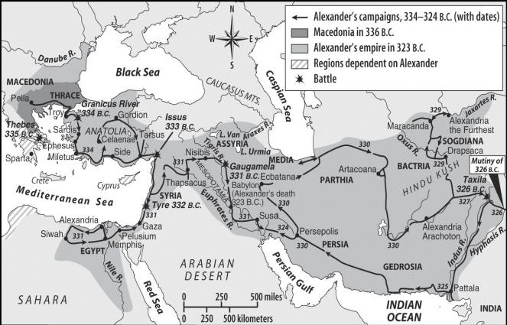

**A Hoplite Soldier’s Shield**

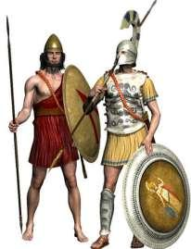**Defenders of Greece**

You’ve been training as a Greek Hoplite soldier since you were seven years old. You’ve spent countless hours marching in a phalanx preparing for the day when you’ll REALLY have to fight to protect your city-state.

Now that you’re 20 years old, you may have to fight at any moment! Of course, you want to be prepared! It’s time to design and “paint” your Hoplite shield!

Remember, Hoplite soldiers put fierce animals, faces of Greek gods, or monsters on their shields to freak out their enemies. Who would dare fight a long phalanx of Greek soldiers with all those nasty images staring them in the face? Persians and Macedonians… Run for your lives!

*Follow the rubric on the back of this sheet and you’re assured to win the battle… And get an “A” on this Hoplite Shield Project!*

May the gods of Mount Olympus be with you!

**Guidelines To Remember:**

**#1. Artwork must be original. You may get ideas from the Internet, clipart, and/or books. However, all artwork that is handed in must be your own!**

**#2. Use the circle on the page provided for your shield. Do not use another sheet of paper or poster board!**

**#3. The entire “shield” must be colored! No white paper can be showing!**

**#4. Neatness counts!**

**#5. Fierceness counts! Your goal is to create an image of an animal, Greek god, hero, or monster that is so fierce your enemies will run without fighting!**

Examples of Some Hoplite Shield Designs



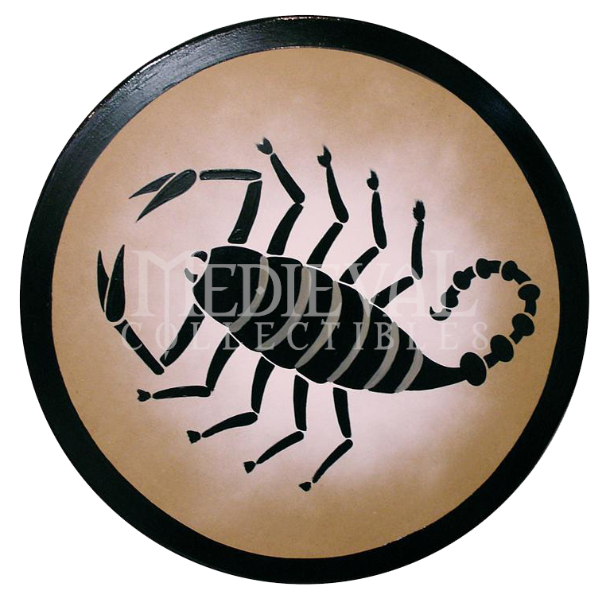



**Hoplite Soldier Rubric**

**10 Points Possible!**

|  |  |  |  |  |  |  |
| --- | --- | --- | --- | --- | --- | --- |
| **Category** | **5** | **4** | **3** | **2** | **1** |  |
|  |  |  |  |  |  |  |
|  | Picture on | Picture on | Picture on | Picture | Picture on |  |
|  | shield is an | shield is a | shield is | on shield | shield should |  |
|  | exceptionally | fierce | of average | is not | be used in a |  |
|  | fierce | animal, | fierceness. | fierce. | Greek comedy |  |
|  | animal, | Greek god, | Greek | Greek | and not in a |  |
| **FIERCENESS** | Greek god, | monster, or | Hoplite | Hoplite | phalanx. The |  |
| monster, or | image. | enemies | enemies | Greeks will |  |
|  |  |
|  | image. | Hoplite | would | would | lose the battle! |  |
|  | Greek | enemies | fight but | fight the |  |  |
|  | Hoplite | might think | lose once | Greeks |  |  |
|  | enemies | about | the battle | and |  |  |
|  | would turn | fighting but | began! | probably |  |  |
|  | and run | would turn |  | win! |  |  |
|  | without | and run at |  |  |  |  |
|  | fighting! | the last |  |  |  |  |
|  |  | minute! |  |  |  |  |
|  |  |  |  |  |  |  |
|  | Shield is | Shield is | Shield is | Shield is | Shield is |  |
|  | exceptionally | neat and | of average | not very | sloppy and |  |
|  | neat and | professional. | neatness. | neat. | unprofessional. |  |
|  | professional. | All artwork | Most | Most | Artwork is not |  |
|  | All artwork | is original. | artwork is | artwork | original. |  |
|  | is original. | Four | original. | is not | Only one color |  |
| **NEATNESS** | At least 5 | different | Three | original. | is used. |  |
|  | different | colors are | different | Two | More than half |  |
|  | colors are | used. | colors are | different | of the shield is |  |
|  | used. | Very little | used. | colors | white. |  |
|  | No “white” | “white” | There is | are used. |  |  |
|  | space is | space is | “white” | There is |  |  |
|  | showing. | showing. | space | a lot of |  |  |
|  |  |  | showing. | “white” |  |  |
|  |  |  |  | space |  |  |
|  |  |  |  | showing. |  |  |
|  |  |  |  |  |  |  |

**= __________ Points Total**

*\*\*\*For an additional 20 bonus points. Take your Shield artwork and create a life-size shield using cardboard or poster board. Bring into class to show off your Artisan Shield making skills!!*

**Hoplite Shield**



*Use this circle to create your shield. Remember to look over the guidelines and rubric to score an “A” If you need more copies of this template, please ask the teacher. Now Become an Artisan!!*

**LapBooking Project: Ancient Greece**



**What is a lapbook anyway?**

A lapbook is a collection of mini-books from a particular study topic that has been gathered and displayed in a folder-book that fits in your lap.

You will be asked to complete a lapbook about Ancient Greece. First, you need to do some research so you can gather enough interesting information to put your project together. For each of these topics, you’ll make a mini-book that highlights the facts you’ve found about that topic (Use the Websites listed below for help on how to create a lapbook). Each mini-book can come in different shapes and sizes. They can pop up; be a series of folds; pocket-style, etc. Be creative with your designs! Each mini-book should reveal interesting information about that topic. You should also add graphics that make it look amazing. These can be hand-drawn, computer printouts, magazine scraps, etc.

Here is a list of topics you can choose from but the true list is endless. Feel free to use as many as you wish, depending on the space you have.

Gods and goddesses:

* Zeus
* Apollo
* Helios
* Athena
* Hera
* Aphrodite
* Poseidon
* Hermes
* Hades

Things Mythological:

* Minotaur
* Ikarus
* Medusa
* Kraken
* Pegasus
* King Midas
* Heracles ( Hercules)
* Achilles
* The Titans

Military:

* Trojan War
* Peloponnesian Wars
* Athens Vs. Sparta
* Persian Wars
* Greek Soldiers/Armies
* Weaponry



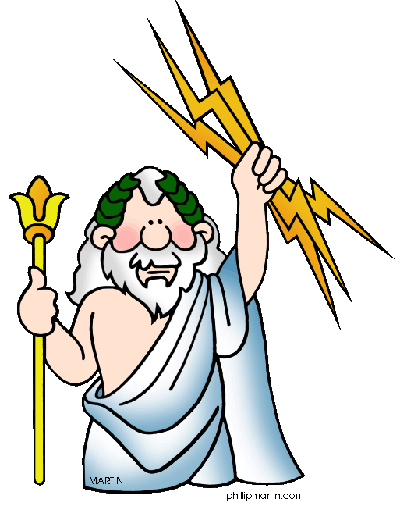



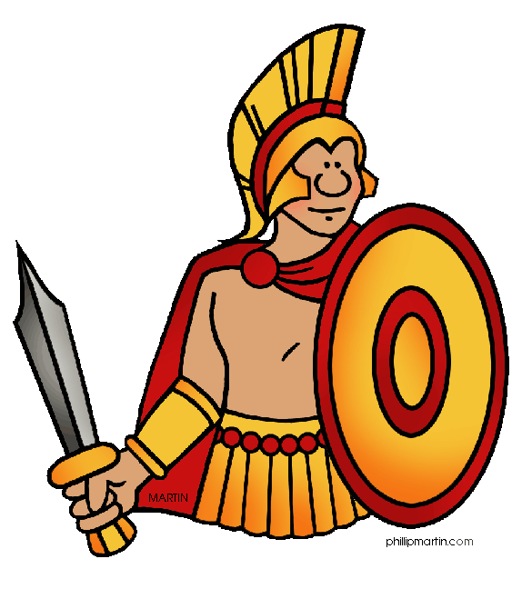



Important People:

* Herodotus
* Plato
* Aristotle
* Alexander The Great
* Socrates
* Homer
* Pythagoras
* Pericles
* King Leonidas
* Themistocles

Society:

* Roles of Men, Women, and Children
* Clothing
* Foods
* Education
* Games/Olympics
* Greek alphabet
* Art, Music, and Theatre

Technology/Miscellaneous:

* Farming (Tools/Methods)
* Temples & Monuments
* Housing
* Toilets ☺
* Maps
* Timelines

Once you’ve prepared a series of mini-books about your topic, you’re ready to add them to your lapbook base (made from file folders). Arrange the mini-books as you see fit but your goal should be to make the entire lapbook fascinating. Use a wide variety of craft materials and add your own creative ideas to the finished product.

Looking to go the extra mile? Check out this website for an endless list of ideas and web links for making your lapbook phenomenal! <http://www.squidoo.com/lapbooking#module2304669>

**How to Fold a Lapbook**

Watch this video here: <http://www.youtube.com/watch?v=7qlys-dZzrI>

Or follow these directions. There are plenty of ways to create lapbooks….Have fun with it!!



1. For each lapbook, you will need a file folder. Open up the folder.

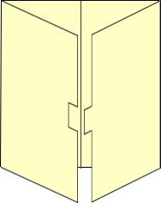

**2.** Fold each side in to meet in the middle. You will glue each of the activities into this to make a lapbook.



3.If you need additional room, you can add an extension. Use a sheet of card stock, or cut a file folder in half. Use wide packing tape to tape it to the top of your lapbook. Fold it down to close the book.

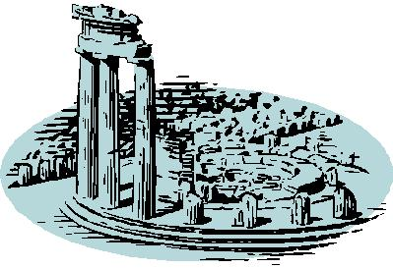

|  |  |  |  |  |  |  |  |  |  |  |  |  |  |
| --- | --- | --- | --- | --- | --- | --- | --- | --- | --- | --- | --- | --- | --- |
| **Criteria** |  | **Level 1** |  |  | **Level 2** |  | **Level 3** | |  |  | **Level 4** |  |  |
| **Research: content** | D- | D | D+ | C- | C | C+ | B- | B | B+ | A- | A | A+ |  |
|  |  Mini-books are missing, | | |  Mini-books offer some | | |  Mini-books cover the topics | | |  Mini-books go into great | | |  |
|  | incomplete or reveal is very | | | relevant information but | | | adequately; reader gets a | | | detail about the topic | | |  |
|  | limited amount of | |  | barely scratch the surface; | | | good sense of what is trying | | | featured; few if any | |  |  |
|  | information; more | |  | more detail is needed. | | | to be shared. | |  | questions are left | |  |  |
|  | researching was required. | | |  |  |  |  |  |  | unanswered. | |  |  |
| **Research: variety** | D- | D | D+ | C- | C | C+ | B- | B | B+ | A- | A | A+ |  |
|  |  Information presented is | | |  Information presented had | | |  Information was plentiful | | |  Information presented | | |  |
|  | irrelevant or very narrow in | | | some variety but more | | | and varied; reader gets a | | | covers a wide range of | | |  |
|  | scope; more researching | | | topics could have been | | | wide spectrum of | |  | topics with a high level of | | |  |
|  | was required. | |  | factored into the lapbook. | | | information from the | |  | intrigue; mini-book topics | | |  |
|  |  |  |  |  |  |  | lapbook. |  |  | were carefully chosen. | | |  |
| **Layout &** | D- | D | D+ | C- | C | C+ | B- | B | B+ | A- | A | A+ |  |
| **Presentation** |  Lapbook is messy and/or | | |  Lapbook may have been | | |  Lapbook has been carefully | | |  Lapbook has been planned | | |  |
| poorly constructed; there | | | rushed; layout is | |  | planned and has many | | | very carefully with a special | | |  |
|  |  |  |
|  | are many empty spaces | | | uninteresting or not clearly | | | added features to make it | | | attention to detail; a wealth | | |  |
|  | and little has been done to | | | thought out; only some | | | look organized and | |  | of planning went into the | | |  |
|  | make it appealing. | |  | attention has been paid to | | | appealing. |  |  | layout and presentation. | | |  |
|  |  |  |  | presentation. | |  |  |  |  |  |  |  |  |
| **Ideas, Time &** | D- | D | D+ | C- | C | C+ | B- | B | B+ | A- | A | A+ |  |
| **Effort** |  Very little time and effort | | |  Some time and effort have | | |  Lapbook has been | |  |  Almost every aspect of the | | |  |
|  | have been invested; | |  | been added but it could | | | completed with care and | | | lapbook has been attended | | |  |
|  | virtually no creative ideas | | | have used more; few | | | effort; a great deal of time | | | to; it is clear there is a lot of | | |  |
|  | have been added. | |  | creative ideas have been | | | has been invested; some | | | creative energy invested in | | |  |
|  |  |  |  | added. | |  | creative ideas have been | | | the project. | |  |  |
|  |  |  |  |  |  |  | added. |  |  |  |  |  |  |

**Lapbook Rubric**