Mrs. Holodick

6th Grade Social Studies

Room #3

Name: __________________________

Period: ________

Chapter 8

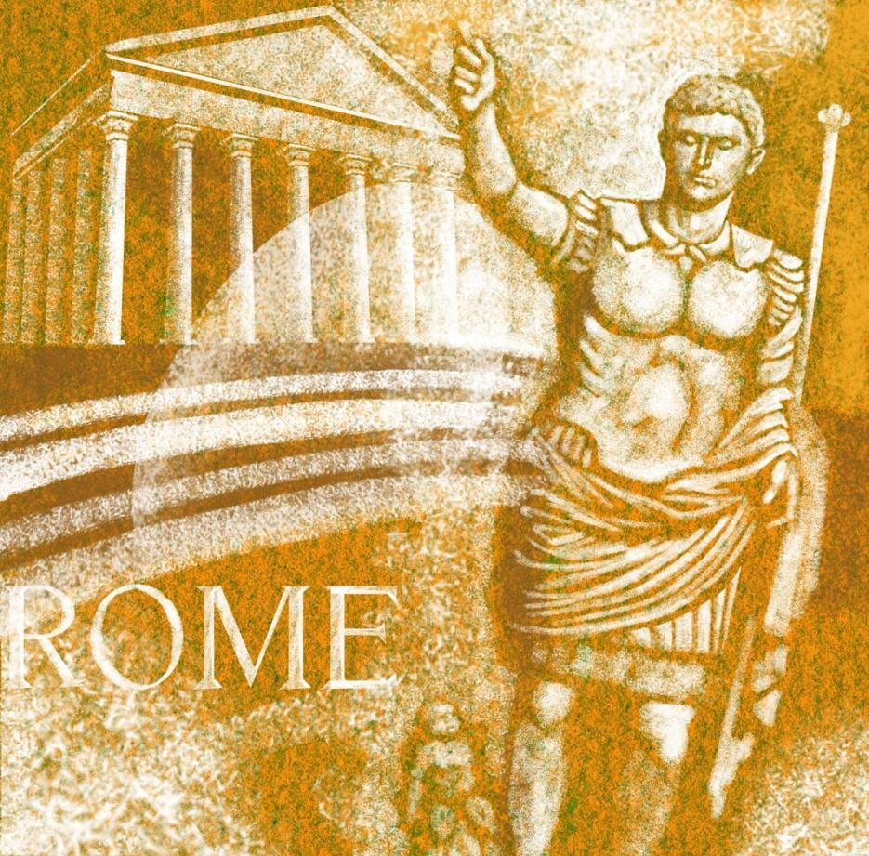

Rise of Rome

Chapter 8: The Rise of Ancient ROME

* Level 1 assignments are required for all classes (everyone)
* Level 2 assignments are required for honors classes, but optional for non-honors classes. If completed, They will be counted as extra credit for non-honors
* Level 3 Assignments are optional, but will be counted as extra credit if completed.
* Any extra credit assignments will not be counted unless all required work is completed
* Packet points will be added up and divided into the total number available. The percentage will be counted as a test grade.

Level 1 Assignments: All Level 1 Assignments Are Required For Everyone!! (100 Total Points Available)

1. ________/15 Points: Rise of Rome Vocabulary Due Date__________- Packet Page 3

2. ________/10 Points: Map of Ancient Rome Due Date __________ - Packet Pages 4 & 5

3. ________/10 Points: Section 1 Notes Due Date __________- Packet Pages 6

4. ________/25 Points: Section 1 Guided Reading & Review Due Date __________- Packet Pages 7 & 8

5. ________/15 Points: Section 2 Notes Due Date __________- Packet Pages 9 & 10

6. ________/25 Points: Section 2 Guided Reading & Review Due Date __________- Packet Pages 11 & 12

Level 2 Assignments: Required For Honors, Optional for Non-Honors Students (20 Total Points Available)

1. ________/20 Points: Imperial Rome Timeline (Directions on Page 13)

Level 3 Assignments: These assignments are optional, but if completed will count as extra credit toward your total point value. Will only be counted if Level 1 and 2 assignments are completed (20 Total Points Available)

1. ________/20 Points: Roman Newspaper (Directions on Page 14)

Vocabulary

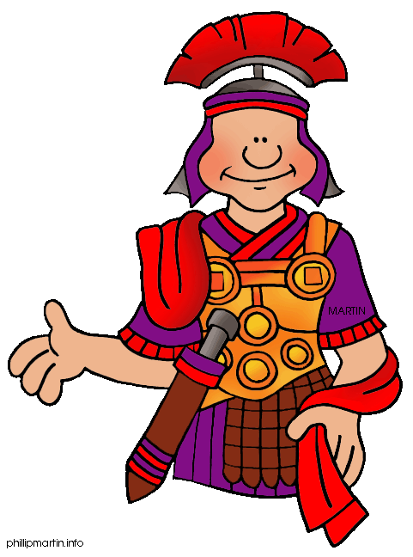

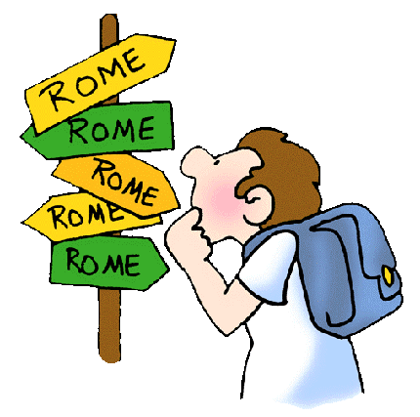

Chapter 8: The Rise of Ancient roME

Section 1: *The Roman Republic*

**Republic - _______________________________________________________________________________**

**________________________________________________________________________________________**

**Patrician - _______________________________________________________________________________**

**________________________________________________________________________________________**

**Plebian - ________________________________________________________________________________**

**________________________________________________________________________________________**

**Consul - ________________________________________________________________________________**

**________________________________________________________________________________________**

**Veto - ______________________________________________________________________________**

**________________________________________________________________________________________**

**Dictator - _______________________________________________________________________________**

**________________________________________________________________________________________**

Section 2: *The Roman Empire*

**Province** - _______________________________________________________________________________

________________________________________________________________________________________

**Colosseum - _____________________________________________________________________________**

**________________________________________________________________________________________**

**Aqueduct - ______________________________________________________________________________**

**________________________________________________________________________________________**

**Polytheism - _____________________________________________________________________________**

**________________________________________________________________________________________**

**Arch - __________________________________________________________________________________**

**________________________________________________________________________________________**

**Map of Ancient Rome**

**Lands of the Mediterranean**

You are about to find out that Rome was the largest and most powerful civilization of the Ancient Mediterranean World! In this map activity, you’ll find out just how *BIG*! You’ll see how theRoman Empire circled the Mediterranean Sea from AsiaMinor to Greece to Gaul to Britain. No wonder the Romans called the Mediterranean *“Our Sea.”* Mare Nostrum!

**#1. Label your map “MAP OF ANCIENT ROME”**

**#2. Label the following LOCATIONS on your map by their Number:**

**#1 Mediterranean Sea #13 Asia Minor**

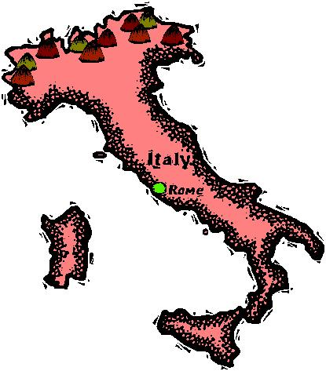**# 2 Atlantic Ocean #14 Egypt**

**# 3 Black Sea #15 Libya**

**# 4 Africa #16 Crete**

**#5 Nile River #17 Gades**

**#6 Mauretania #18 Londinium**

**#7 Italy #19 Spain**

**#8 Britain #20 Rome**

**#9 Gaul #21 Athens**

**#10 Germany #22 Dacia**

**#11 Alexandria #23 Thrace**

**#12 Carthage #24 Greece**

**#3. Color all of the LAND that belonged to Rome ONE color!**

**#4. Color all of the LAND that did *NOT* belong to Rome a SECOND color!**

**#5. Notice that all the WATER is already colored in GREY for you! Just Label the Bodies of Water.**

**Look on page 227 of your book to find these locations on your map!**

**#6. Color your MAP KEY the appropriate colors!**

**TAKE YOUR TIME!**

**BE NEAT AND ACCURATE!**

NOW FILL IN THE ROMAN EMPIRE!!!

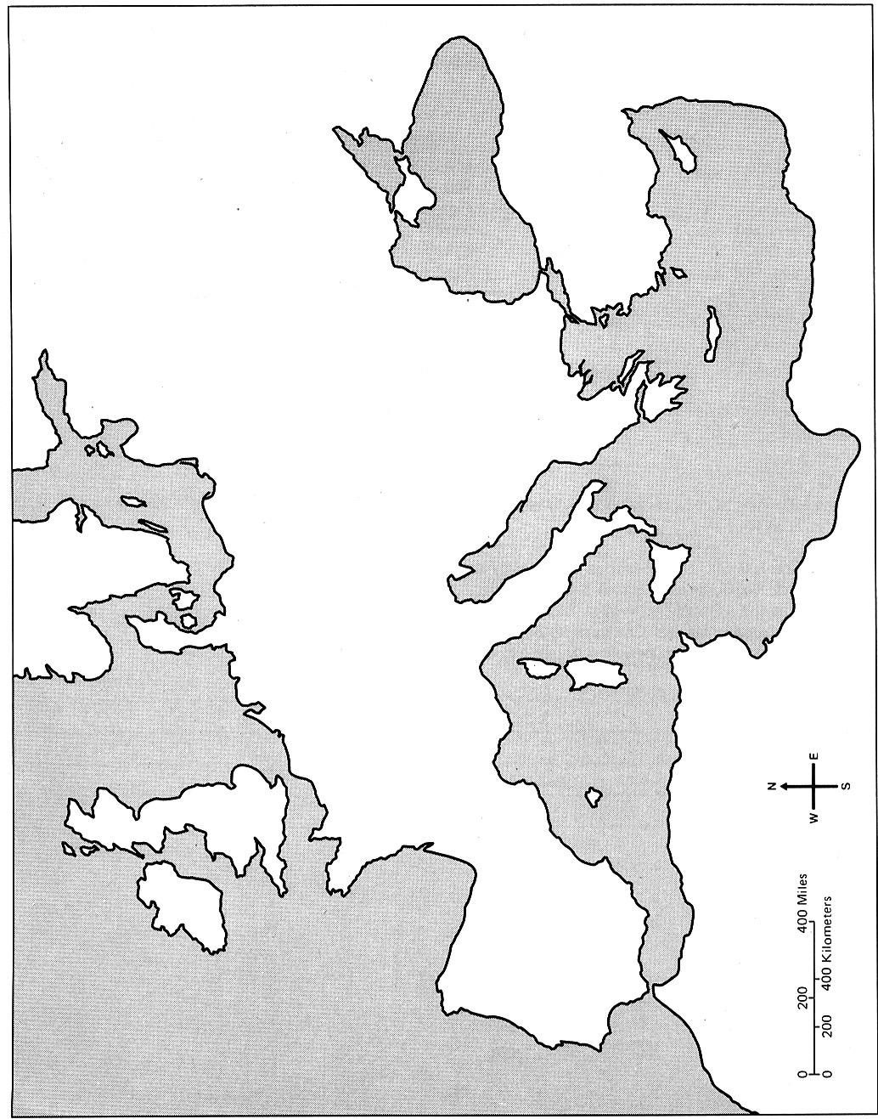

**MAP KEY**

 LAND OF ROME

NOT Roman Land

Water

The Roman Republic (Section 1) Notes

**The Roman Republic**

**Chapter 8, Section 1**

**Directions: Using class discussions and your textbook pages 228-235, fill in the blanks with the correct information**

**Critical Thinking Questions:**

1. Describe the legend of Romulus and Remus _________________________________________

_______________________________________________________________________________

_______________________________________________________________________________

2. What did the Romans value? _____________________________________________________

3. What happened to people who broke the Law? _______________________________________

4. What are some of the Geographical advantages of Rome’s location?

a) _________________________________________________________________________

b) _________________________________________________________________________

c) _________________________________________________________________________

d) _________________________________________________________________________

e) _________________________________________________________________________

5. Describe where Rome is located ___________________________________________________

_______________________________________________________________________________

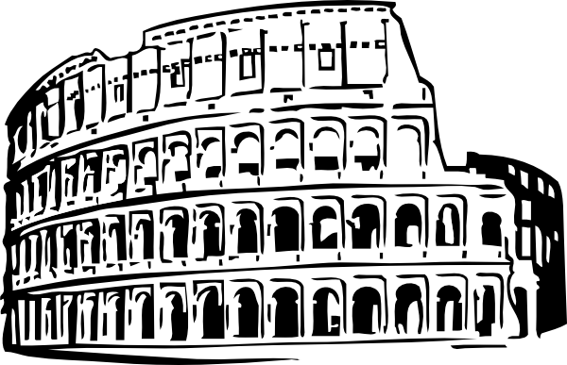

6. Why do you think being surrounded by the Mediterranean Sea would be

an advantage? ________________________________________________

_____________________________________________________________

7. Who held power in Rome about 600BC? ____________________________________________

8. How did the Etruscans rule? ______________________________________________________

9. How did the Etruscans influence Roman life? _________________________________________

_______________________________________________________________________________

10. What was the new form of government the Romans created and why? ____________________

_______________________________________________________________________________

11. Describe the Roman Senate in detail ______________________________________________

_______________________________________________________________________________

12. What were the Roman Consuls responsible for? _____________________________________

_______________________________________________________________________________

13. Why/When did the Romans appoint a Dictator? ______________________________________

_______________________________________________________________________________

14. Who were the Praetors and what did they do? _______________________________________

_______________________________________________________________________________

15. Describe the Patrician Attitude __________________________________________________

_______________________________________________________________________________

16. Describe the Plebeian Attitude ___________________________________________________

_______________________________________________________________________________

17. What happened between the Patricians and Plebeians? _______________________________

_______________________________________________________________________________

_______________________________________________________________________________

18. Why might the Romans have wanted to conquer Carthage? ____________________________

_______________________________________________________________________________

19. As Rome dissolved into civil war, who arose as a strong leader? _________________________

20. Julius Caesar became _________________________ of Rome in 48BC.

21. What happened to Caesar on March 15, 44BC? _____________________________________

22. Why did the Roman Senate kill Julius Caesar? _______________________________________

_______________________________________________________________________________

23. What happened to Rome after Caesar’s death? ______________________________________

24. Who was Octavian? ____________________________________________________________

25. What did the Rule of Octavian “Agustus” mean for Rome? ______________________________

_______________________________________________________________________________

The Roman Empire (Section 2) Notes

I. Governing the Empire

A. __________________________________

1. ________________________________________________________________

2. ________________________________________________________________

B. __________________________________

1. ________________________________________________________________

2. ________________________________________________________________

C. __________________________________

1. ________________________________________________________________

__________________________________________________________________

2. ________________________________________________________________

__________________________________________________________________

D. __________________________

1. ________________________________________________________________

2. ________________________________________________________________

__________________________________________________________________

__________________________________________________________________

3. ________________________________________________________________

__________________________________________________________________

II. Greek influence on Rome

A. _____________________________________________________________________

B. _____________________________________________________________________

III. Architecture and technology

A. _______________________________

1. ________________________________________________________________

2. ________________________________________________________________

__________________________________________________________________

B. Roads and Aqueducts

1. ________________________________________________________________

2. ________________________________________________________________

IV. Roman law

A. ________________________________

1. ________________________________________________________________

2. ________________________________________________________________

__________________________________________________________________

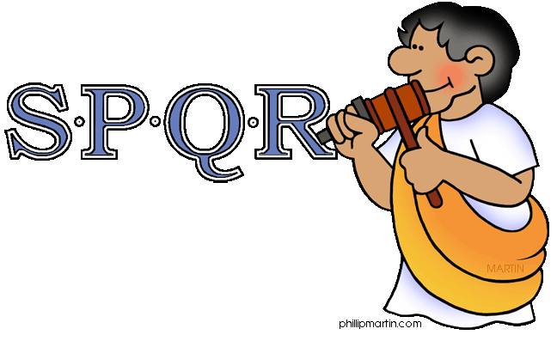

*Did You Know?* After the people of Rome had chased away the last of the Etruscan kings, the people declared Rome to be a republic. *What is a republic?* A republic is a government run by elected officials.

The new government of the Roman Republic ordered the letters SPQR to be chiseled on public buildings, armor, coins, and even park benches. The letters SPQR were chiseled on anything that belonged to the state.

Under the Republic, the state was composed of the Senate and the People of Rome. That's what SPQR stood for - ‘Senatus Populus Que Romanus’ - the Senate and the People of Rome.

It was a publicity campaign, and it worked!  Every time the people saw the letters SPQR, they were reassured that things had changed. The kings were gone. It was a time of new leadership and new government. It was the time of the Roman Republic.

Senātus Populus Que Rōmānus

THe Roman Empire

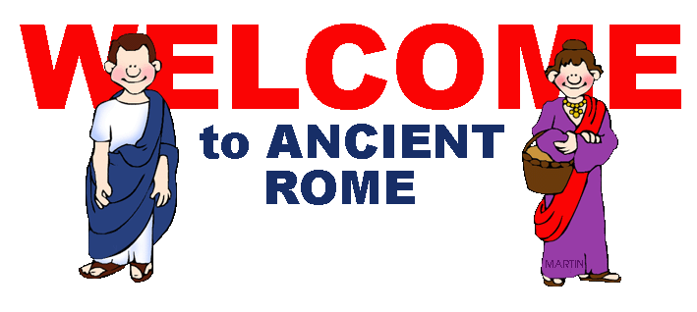

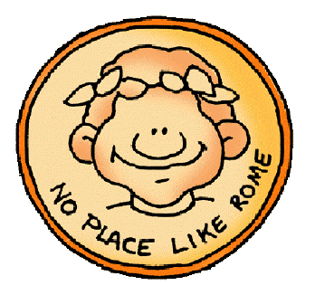

**Chapter 8, Section 2**

**Directions: Using class discussions and your textbook pages 240-246, fill in the blanks with the correct information**

**Critical Thinking Questions:**

1. Describe the Roman Empire: What did they call the Mediterranean Sea? ___________________

_______________________________________________________________________________

_______________________________________________________________________________

2. What kind of leader was Augustus? ________________________________________________

_______________________________________________________________________________

3. Why did August try to avoid acting like a king? ________________________________________

_______________________________________________________________________________

4. What did the Romans give Augustus? ______________________________________________

5. What did the Romans do with Conquered People? _____________________________________

_______________________________________________________________________________

6. How did the Romans govern conquered peoples? _____________________________________

_______________________________________________________________________________

7. Did the Romans treat the conquered peoples fair or unfair? Explain? ______________________

_______________________________________________________________________________

8. Describe Caligula: ______________________________________________________________

9. Describe Nero: _________________________________________________________________

10. Was Hadrian considered one of the “Five Good Emperors?” Why? _______________________

_______________________________________________________________________________

_______________________________________________________________________________

11. Who was Marcus Aurelius? ______________________________________________________

12. Who was Commodus? _________________________________________________________

13. Describe Commodus: __________________________________________________________

_______________________________________________________________________________

14. Compare Roman and Greek Religion ______________________________________________

_______________________________________________________________________________

_______________________________________________________________________________

15. In what ways did the Greeks and Romans value Learning? _____________________________

_______________________________________________________________________________

16. What new building material did the Romans invent? ___________________________________

17. Describe the Colosseum: _______________________________________________________

_______________________________________________________________________________

_______________________________________________________________________________

18. Why was the development of roads important? ______________________________________

_______________________________________________________________________________

19. Describe the Roman Aqueduct: ___________________________________________________

_______________________________________________________________________________

20. Our government is heavily based off of Roman Law. Read the lines below from the *Code of*

*Justinian* and explain their meanings in your own words.

“No one suffers a penalty for what he thinks.”

Meaning: ___________________________________________________________________

“No one may be forcibly removed from his own house”

Meaning: ___________________________________________________________________

“The Burden of Proof is upon the person who accuses”

Meaning: ___________________________________________________________________

“In inflicting penalties, the age and experience of the guilty party must be taken into account”

Meaning: ___________________________________________________________________

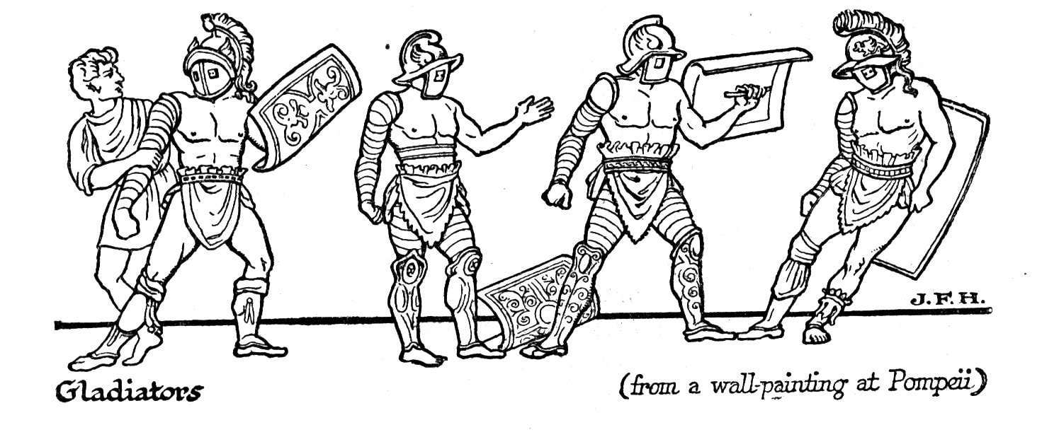

Imperial Rome Timeline

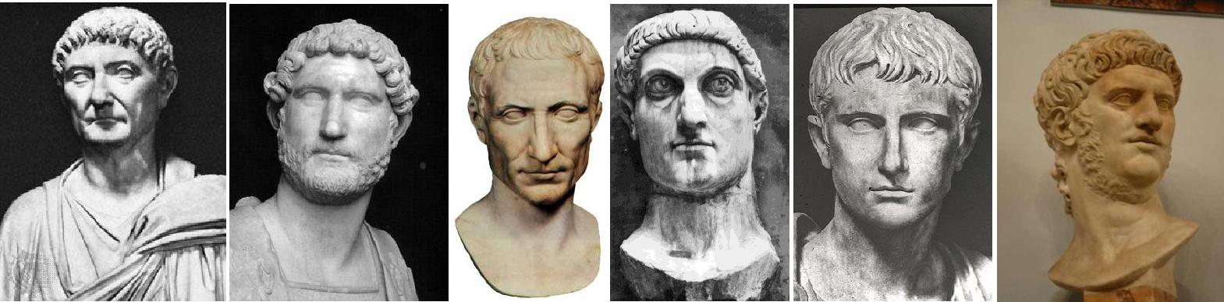

When Julius Caesar became dictator of Rome in 48BC, it marked the end of the Roman Republic and he founded a system of government that led the Roman Empire to glory. You are a Roman historian, living in the final days of the Eastern Roman Empire and you feel the need to record the lives of the Roman emperors for future generations. You’ve picked 9 important emperors that have led Rome, for better or for worse, over the last 1000 years. Create a timeline that shows the growth of imperial power and the issues that come from allowing an infallible (perfect) person to control your government.

Assignment:

1. Use your textbooks, Notes, and/or Internet to research the following emperors: Marcus Aurelius, Diocletian, Commodus, Hadrian, Octavian, Nero, Constantine, Augustus, and of course, the man himself, Julius Caesar.
2. Create a timeline, placing each emperor in the **correct order** (include the year that they rose to the throne).

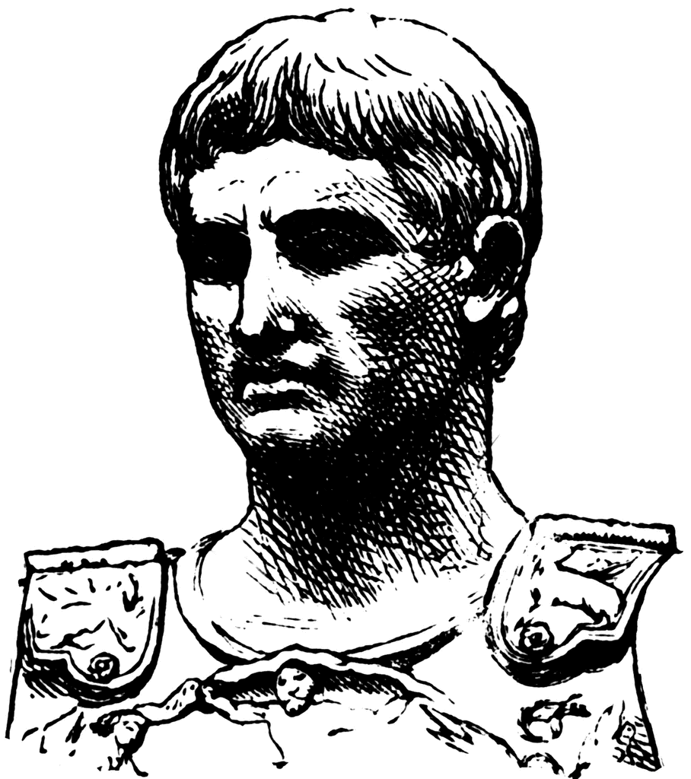

1. For each emperor, list their name and five unique facts.
2. Place a picture or bust (like the sculptures above) of the emperor

Scoring Rubric:

_______ (10 Points) All emperors have been placed in the correct order. All dates have been included and two facts have been provided for each emperor. The assignment is neatly done.

_______ (7 Points) All emperors have been placed in the correct order. Some dates or facts are missing. The assignment is neatly done.

_______ (5 Points) All emperors have been placed in correct order. No dates or facts were provided. The assignment was difficult to read.

_______ (3 Points) The assignment was turned in but did not meet the requirements.

Points Received = _____________

**Ancient Rome:**



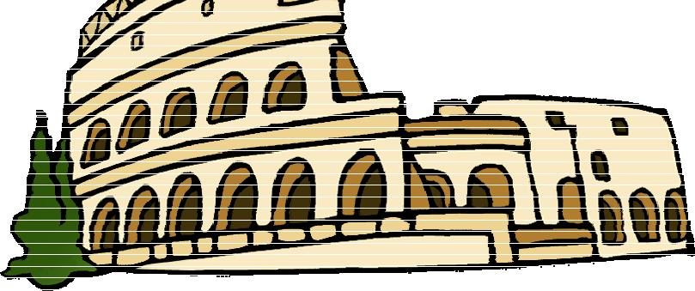**Newspaper Project**

**Task**: For this assignment, you will be designing and producing an Ancient Rome newspaper using Microsoft Word. You will need to use the information acquired during your Ancient Rome Chapter. You will also be required to research some additional information to complete your newspaper at home.



**Must Be Included In Newspaper**:

1. **Content**: Your newspaper must include
   1. a. Ancient Title, News Date, City of Publication



* 1. b. One feature story and headline on an ancient person
  2. c. One sports article and headline
  3. d. One Architecture review
     1. I. What does it look like?
     2. II. What was it used for? Importance?
     3. III. Where is it located?
  4. e. One Ancient Rome war
  5. f. One story on Ancient Rome technological advances
  6. g. Three advertisements
  7. h. Weather information
  8. i. Graphics and/or pictures with captions

1. Plus at least **three** of the following:

*\*\*\*Remember this project should look like a Newspaper. To make it look realistic use Google to search for a Microsoft Word Newspaper Template to get you started. Or you can create your own.*

* 1. a. Classified section
  2. b. Entertainment news
  3. c. Food / Recipe section
  4. d. Fashion and Lifestyle section
  5. e. Travel Information
  6. f. Real Estate listings
  7. g. Cartoon (hand drawn)

|  |  |  |  |  |  |  |
| --- | --- | --- | --- | --- | --- | --- |
| **Feature People Story:** | **Architecture Review** |  | **Sports** |  | **Roman Wars:** |  |
|  |  |  |
| Octavian | **Options:** |  | **Headliners:** |  | First Punic War |  |
| Julius Caesar | Coliseum |  | Gladiators |  | Second Punic |  |
| Nero | Pantheon |  | Chariot Racing |  | War |  |
| Augustus | Arch of Constantine |  | Games (ball & |  |  |  |
| Constantine the Great | Two Hills of Rome |  | Board) |  | **Technology:** |  |
| Etruscans | Tower of Hercules |  |  |  | Concrete, |  |
| Romulus & Remus | Catacombs of Rome |  |  |  | Arches, |  |
| Hannibal of Carthage | Hadrian’s Wall |  |  |  | Aqueducts, |  |
| Spartacus |  |  |  |  | Medicine, Roads, |  |
|  |  |  |  |  | Sewer System |  |
|  |  |  |  |  |  |  |
|  |  |  |  |  |  |  |